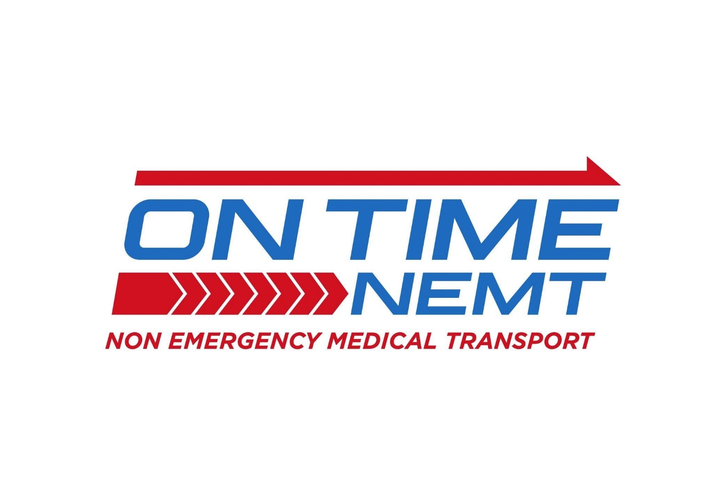Mission & Values
Our Mission
To deliver reliable, on-time transportation with dignity, safety, and genuine care. Every trip is part of someone’s care journey, and we show up prepared, professional, and committed to a consistent, elevated experience for every guest and every facility we serve.
Our Values
People First — Every decision begins with the guest we’re serving.
On Time, Every Time — Reliability is the foundation of our service.
Care in the Details — Small actions create meaningful experiences.
Respect Always — Every guest is treated with dignity and patience.
Safety With Support — We assist every guest with confidence and care.
Professionalism With Heart — We show up prepared, present, and proud.
What This Means for Drivers
Drivers represent the On Time NEMT standard at every moment in the field. Reliability, professionalism, and respectful support are not optional — they define our service.
Every trip should reflect:
- On-time arrival and preparedness
- Calm, respectful, and confident communication
- Safe and thoughtful assistance
- A clean, organized, and professional vehicle
- Pride in the experience we provide

Our Service Philosophy
We are not simply providing transportation.
We are supporting care, independence, and trust.
Guests, families, and facilities depend on us to show up on time, communicate clearly, and treat every person with patience and dignity. Small details, consistent professionalism, and dependable service define the On Time NEMT experience.

Driver Promise (3 Core Commitments)
- Arrive prepared and on time for every trip
- Deliver safe, responsible transportation, safety always comes before speed
- Get to know our guests and create a respectful, familiar, and personal experience every time

Guest Experience Standard
Every guest interaction should reflect reliability, safety, respect, and a personal connection.
Drivers are expected to provide:
- A warm, respectful, and professional welcome
- On-time, dependable transportation that prioritizes safety over speed
- A calm, unhurried experience that supports comfort and confidence
- Thoughtful support from pickup to handoff
- A familiar, personal experience by getting to know our guests and their needs over time
- Clear communication and reassurance throughout the trip
On Time NEMT operates on an “on time every time” standard while maintaining that safety, proper assistance, and genuine care always come before rushing.

Daily Expectations
Drivers are expected to:
- Maintain a clean, organized vehicle
- Wear approved attire and present a professional appearance
- Communicate clearly and respectfully with guests and facilities
- Follow all safety protocols and secure mobility devices properly
- Monitor schedules and protect on-time performance
- Document trips accurately and report issues promptly

How We Show Up
With patience
With professionalism
With genuine care
With reliability
With consistency
With pride in the On Time NEMT brand

